**10 reasons Warwick is the perfect staycation destination**

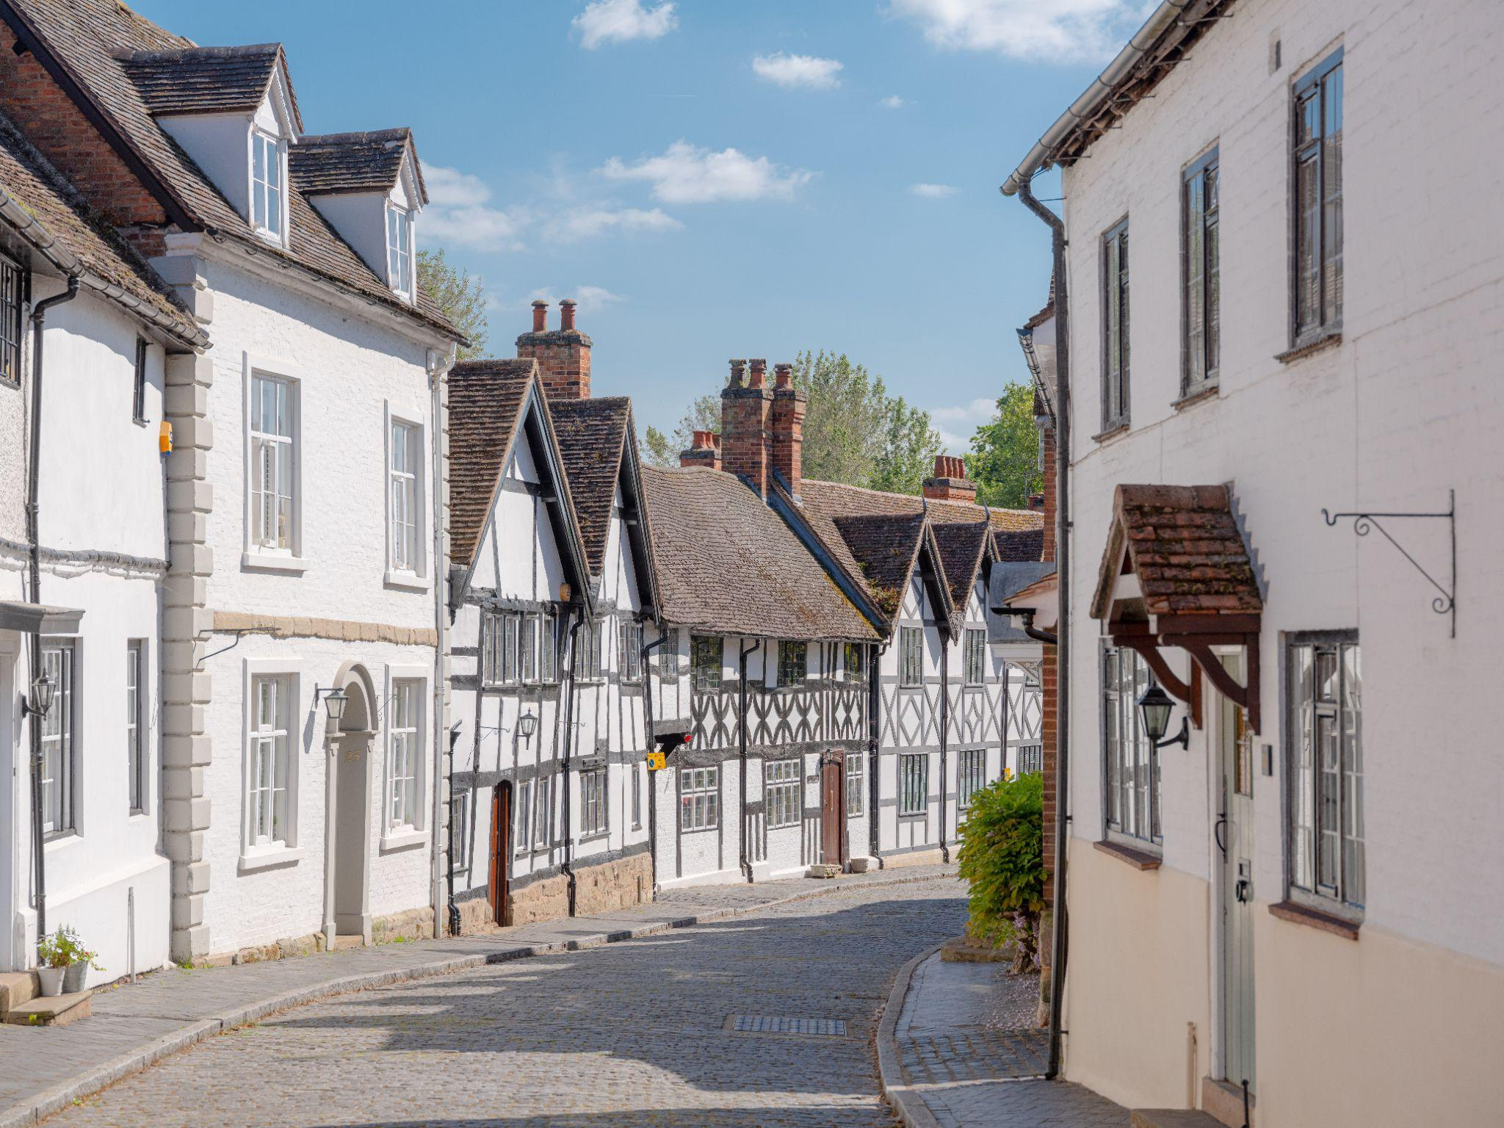

When it comes to a weekend break, it doesn’t get much better than Warwick. This traditional market town in the heart of England is home to cultural landmarks that appear in history books through the ages, from the town’s castle to its Victorian walled gardens and mediaeval buildings.

Visitors can explore cobbled streets, hidden historic highlights and Warwick’s Market Square that is still home to a Royal Charter Market or attend some of its many events including a traditional folk festival and Victorian Evening.

On top of these, there’s an array of restaurants and cafes from fine dining to casual restaurants and cuisine from across the world, as well as cosy traditional pubs, independent shops selling everything from antiques to books and clothing, plus one of the oldest racecourses in the country.

From walks in Warwick’s picturesque parks to overnight stays in a range of boutique accommodation from four-poster beds to revamped rooms in historic buildings, here are 10 reasons why Warwick is the perfect staycation destination.

**1. Soak up key historic sites**

Warwick is well known for its castle, which at over 1,000 years old is the best preserved fortress in England, but there are many more historic sites in this mediaeval market town to see when you visit.

After a devastating fire at the end of the 17th century, much of Warwick had to be rebuilt. But one of the oldest surviving buildings is the grand Lord Leycester Hospital on West Gate. This collection of Grade I listed buildings date back to the 13th century and has had many uses over the years, from housing medieval guards and later ex-military men to hosting balls and parties.

Hidden behind the hospital is the enchanting Master’s Garden. As well as its impressive floral displays, the garden is reputed to contain a 2,000-year-old Egyptian ‘Nilometer’, a stone urn which crowned one of the columns on the river Nile, used for measuring floods. Famous visitors captured by the garden’s beauty include Charles Dickens, Charles Darwin and Oscar Wilde.

The historic site is currently undergoing an extensive refurbishment which will make it a must-visit attraction but still makes the perfect picture as you eye up its impressive frontage.

<https://www.lordleycester.com/>

<https://www.warwick-castle.com/>

**2. Tour cobbled streets and hidden historic highlights on a town trail**

Warwick is steeped in history and its interesting architecture, from medieval buildings to Georgian townhouses, make it picture-perfect for a wander around. The perfect way to take in the town’s highlights and hidden gems is through its Town Break Trail - a 48-hour trail including its historic buildings and quirky cultural hotspots. Plan a weekend around the trail or dip in and out as you please in between other activities and fun.

There’s also the Guy of Warwick trail, which brings one of English history’s most famous love stories to life. Dubbed ‘England’s Forgotten Hero’, the story of Guy of Warwick dates back to the 10th Century and is full of drama, romance and tragedy. The trail, produced by the town’s Guy of Warwick Society, leads visitors around the town, encouraging them to solve puzzles and find clues, with the free augmented reality app allowing people to hear the hero himself explain his life and adventures.

Both trails are available online as well as in paper format from Warwick Visitor Centre.

<https://www.visitwarwick.co.uk/>

**3. Climb 134 steps in one of Warwick’s finest buildings for panoramic views**

Visit Warwick’s Collegiate Church of St Mary and you’ll be in one of the largest churches in Britain, which celebrates 900 years of history in 2023. When open to visitors, you can climb 134 steps up the church tower to see glorious views of the town and the surrounding Warwickshire countryside.

St Mary’s also houses a Norman Crypt, the tomb of Richard Beauchamp (the 13th Earl of Warwick who supervised the trial and execution of Joan of Arc), and one of only two remaining mediaeval ducking stools - used to see if a woman was a witch or not - in England.

<http://www.stmaryswarwick.org.uk/>

**4. Dine on fabulous food and drink**

When it comes to food and drink, Warwick has it all. Tailors Restaurant, whose home is in a former gentlemen's tailors shop in Warwick's historic Market Place, is featured in the Michelin Guide and serves up tasting menus using locally sourced and foraged ingredients

Nearby, award-winning restaurant Dough & Brew regularly appears in lists of England’s best pizza restaurants, while The Pickled Crab on Smith Street serves fish caught off Britain’s shores as well as other local produce. Other Warwick restaurants include quirky La Mesa, a Spanish-inspired restaurant serving a set menu that changes daily depending on what ingredients are available, while popular Thai restaurant The Art Kitchen is a fond favourite with locals and visitors.

Elsewhere, Warwick is the perfect place for everything from a full English breakfast to a traditional Sunday roast, with everything else in between from brunch to lunch and afternoon tea. For cocktails pop into Ironworks or Ronnie’s, Warwick’s premier live music venue with a beautiful outdoor terrace. Bonito’s is a chic neighbourhood wine bar serving cheese and charcuterie boards and if G&T is your tipple, don’t miss That Gin Bar.

<https://www.buyin2warwick.co.uk/eat-drink-sleep>

**5. Take in Glorious Gardens**

Warwick is home to the historic Hill Close Gardens - rare surviving Victorian gardens once used by townsfolk who lived above their businesses to escape from the crowded town. There they grew fruit, vegetables and flowers as well as keeping pigs and poultry, as well as building summerhouses so they could sit and enjoy the views.

In the early 20th Century, part of Hill Close Gardens was sold off for housing but the remainder was saved from destruction by the concerted efforts of neighbouring residents, supported by the District and Town Councils, and it is now a site of national importance.

At the end of Mill Street, lined by 15th and 16th century buildings, you will find Mill Garden. Famed for the quality of its planting and breathtaking position on the banks of the River Avon, beneath the walls of Warwick Castle, it was created over a period of 60 years by the late Arthur Measures as a personal expression of his love of plants.

<https://www.visitwarwick.co.uk/the-mill-garden/>

<https://hillclosegardens.com/>

**6. Spend a day at the races**

For a traditional day at the races, walk just a few minutes from the town centre to Warwick racecourse. Nestled near to the castle, it is one of the oldest racecourses in the country, with its first race having taken place here in the 1700s.

Today it’s a National Hunt racing course and has a programme of 25 meetings throughout the year, many of which are televised. Of course, a day at the races is also an excuse to get dressed up and drink champagne. Whatever your budget, there is a package for everyone, from regular race day tickets to elegant hospitality suites. You can even arrive by helicopter if you’re really splashing out.

<https://www.thejockeyclub.co.uk/warwick/>

**7. Experience unique events**

Warwick plays host to a packed programme of events throughout the year, from its world-famous Folk Festival to its unique Victorian Evening that kicks off the festive season and takes the town back in time, with a Victorian fair and a procession of dignitaries in period costume to mark the switching on of the Christmas lights.

Warwick is one of the few remaining towns in England to still have a traditional Court Leet which hosts community events throughout the year including the Warwick Beer Festival and Classic Car Show that brings hordes of classic cars showcasing British engineering into the town centre, while the Guy of Warwick Festival celebrates the town’s legendary figure. Alongside all of this, the Warwick Words History Festival and Warwick Thai Festival are unique events you won’t find elsewhere.

<https://www.visitwarwick.co.uk/whats-on/>

<https://www.warwickdc.gov.uk/events/event/201/warwick_victorian_evening>

**8. Shop until you drop**

Warwick is teeming with independent shops, and there are treasures to be found no matter what your interest. From clothing to antiques, books and more, there really is something for everyone. Warwick has two antiques centres packed with quality stock, while book-lovers will love browsing independent bookshop Warwick Books. Golden Monkey Tea Company sells over 120 loose leaf teas. Pillows and Porcelain is where to head for vintage crockery - also available to hire for your own afternoon tea parties - while Greenbean is a sustainable shop selling food, gifts, and household goods that are kinder to the planet.

Warwick is also home to a Royal Charter Market in its traditional market square every Saturday, plus an array of events throughout the year.

<https://www.buyin2warwick.co.uk/shops-and-businesses>

**9. Take a traditional rowing boat down the river**

There’s nothing more quintessentially English than rowing down the river and taking in the views. The town sits on the picturesque River Avon and you can spend time on the water by hiring canoes, rowing boats and even pedalos and paddleboards.

The view of Warwick Castle from the river is one of the most impressive, and the perfect way to get a similar perspective to the vista that inspired Canaletto to paint the scene.

<https://warwickboats.co.uk/>

**10. Check out your favourite TV and movie backdrops**

Warwick and its historic buildings have been the perfect backdrop for multiple

television series - including many much-loved period dramas. The BBC’s drama series Dangerfield and dramas Pride and Prejudice, Tom Jones, and Moll Flanders were all filmed here. Parts of the town even substituted for Elizabethan- and Jacobean-era London in the BBC’s Doctor Who.

Filming also took place in June 2019 for A Christmas Carol, which was broadcast on UK television at Christmas of that year. You may also spot the Blue Plaque erected in recognition of J.R.R. Tolkien’s association with Warwick. The author was married in Warwick’s Catholic Church of Saint Mary Immaculate and is said to have been very influenced by the town. It’s even thought to have inspired ‘The Shire’ in his famous hobbit books.

-ENDS-

**EDITORS NOTES**

A folder of images of Warwick for media use is available here <https://drive.google.com/drive/folders/1_daax5hyMPYl0sn8UI3hN1ZAwYu2yFnD>

For all press enquiries, images and to discuss press trips, please contact

Ellen Manning at EMPR on 07515 717173 or [ellen@weareempr.co.uk](mailto:ellen@weareempr.co.uk)

**About Warwick Chamber of Trade**

Warwick Chamber of Trade (@buyin2warwick) represents businesses in Warwick with the aim of promoting them, and the town as a whole, locally, nationally and internationally.

Find out more here: <https://www.buyin2warwick.co.uk/buyin2warwick>

You can also follow BuyIn2Warwick on Instagram here: <https://www.instagram.com/buyin2warwick/>